PROGRAMME
Friday, June 21st, 2019
Latest arrival of participants, accommodation
19:00 Meeting with your hostess at the reception of your hotel
Transfer to the Welcome Party, either by Metro or by tram. You will receive tickets for transportation for each member of your group.

19:30 - 22:30 Welcome Party at:
Staropramen Brewery, Nádražní 84/43, 150 54, Prague 5
The Pasp Hall

Approx. 20:00 - Official opening of 10th Old Prague Ham
20:30 Dinner (pork steak in garlic and herb sauce, potatoes, nuts, chips etc. and UNLIMITED BEER ! Who is gonna be the best within 3 hours?
20:45 Special surprise

Connection: Metro B Line (the yellow one), Station Anděl (front exit Na Knížecí) or Tram No.(7, 12, 14, 20, 54)
GPS: 50.0685447N, 14.4065544E
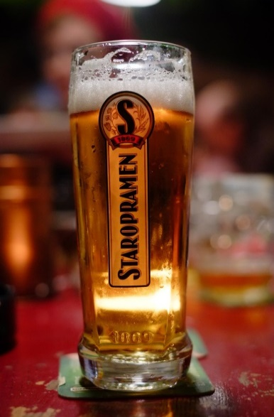
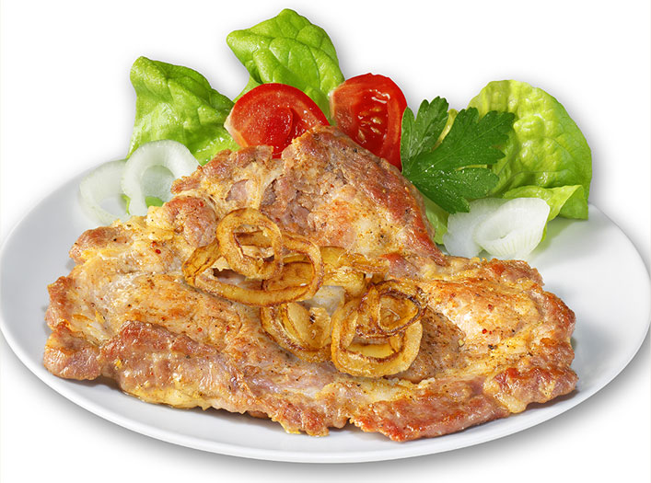

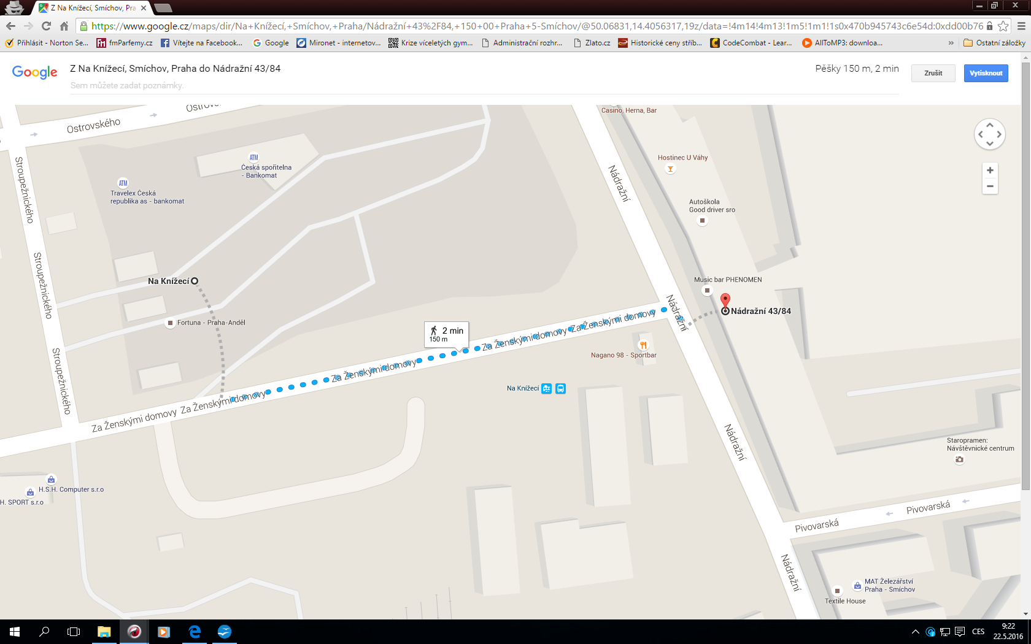

Saturday, June 22nd, 2019

08:00-09:00 Departure of teams from hotels to the Old Prague Ham Tournament
Exact departure time for your team you receive in the separate e-mail !!!
Your hostess will be ready at the reception and help you and travel with you from
your hotel to the rugby pitches.

Transfer will be provided by bus to:
Rugby Club MOUTFIELD, Široká 150/22, Říčany
www.rugbyricany.cz
09:15 Captains and referees meeting – finalizing the rules and everything for the
Match day
09:30 First matches start
You will receive matches schedule on Friday welcome party (at the latest) and also by e-mail.
Each participant will receive in the beginning of the day one 0,5 l bottle of drinking water water. You can refill these bottles from tank with drinking water.
Each participant can buy for 2,-EUR or 50,-CZK RETURNABLE CUP with motifs from our tournament. You can use this cup for your beers, water and any other drinks and at the end of the day you can return it at the beer serving places and you will get your deposit of 2,-EUR or 50,-CZK back.
PLEASE HELP US TO PROTECT OUR NATURE AND MAKE MINIMUM PLASTIC AND OTHER GARBAGE. THANK YOU !
Your hostess will assist you with arranging these cups for all your team !

Lunch for teams will be provided: 13:30 – 15:00. UNLIMITED beer consumption will be provided during the whole match day!
Changing rooms will not be locked, so take care of your valuables!
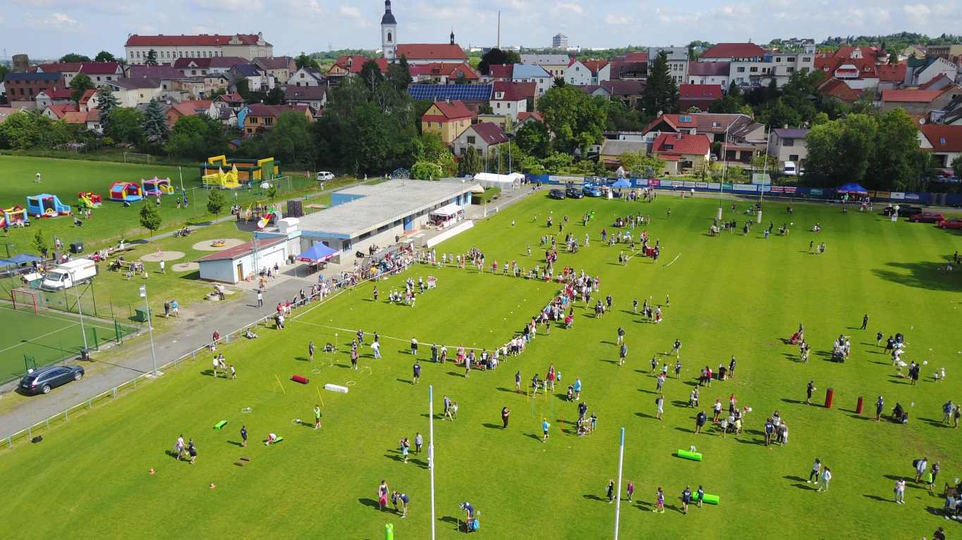
Rugby Club MOUTFIELD Říčany

17:30 End of the rugby match day, closing ceremony, departure to hotels by buses.
Coming to the hotel, leaving your sportswear and continuing by bus for After Party.

19:00 – 23:00 AFTER PARTY in:
Restaurant V rohlíku, Address: Na Hřebenech II., 1130/6 , 140 70 Praha 4 – Podolí

Buffet dinner and UNLIMITED beer consumption!!
Together with concert of: Apples Girls Rock – girls band
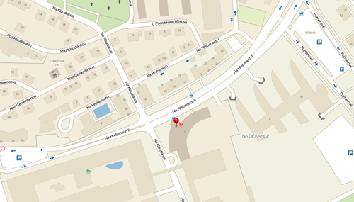
http://www.apples.cz/

Sunday, June 23rd, 2019
Free programme, departure of some partcipants.

Additional information:
All teams will be accompanied by a hostess.
All player will be given a rubber bracelet, which is a „free ticket“ to all events,
Anybody without a ring will not be let in, and what is MUCH WORSE,
WILL NOT BE GIVEN FREE BEER!!!

Contact persons and mobile phone numbers:
Viktor Hlaváč: +420 602 207178
Ondřej Malina: +420 603 536976
Daniela Slušová: +420 604 674070
www.oldpragueham.cz
LIST OF PARTICIPANTS
- Brandenburg Adler Old Boys Potsdam – Germany
- Old Boars – Germany
- Walferdange Rugby Club – Luxembourg
- Les ceps Beaujolais – France
- Abu Dhabi Old Boys RFC – UAE
- Malta Marauders – Malta (4th participation already)
- Kinsale RFC Wild Geese – Ireland
- RK ORB – Ukraine
- Dresden Hillbillies – Germany
- Alte Preussen – Germany
- Old Rugby Teramo – Italy
- Cinghial Old Rugby Como – Italy
- Old Boys Praha – Czech Republic
- Moravian Eagles – Czech Republic (Moravian Region)
- O33 Rugby Říčany – Czech Republic
- Prague Boys – Czech Republic

Main sponzor: The Pernštejn Brewery

